**ECE 254 Homework 5**

**Uncertain Amplitude Signal**

**Name: Mingxuan Wang**

**Date: 2015/11/15**

* Title: Uncertain Amplitude Signal
* Objective:

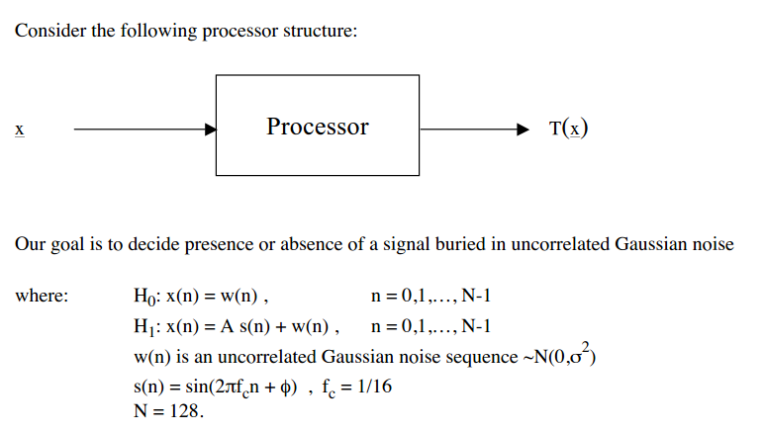



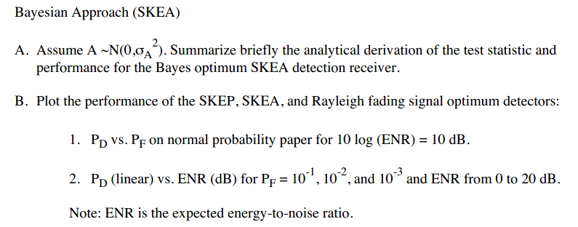

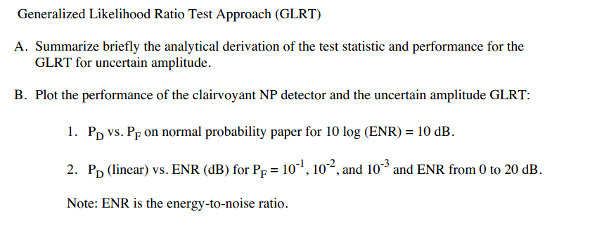

* Approach:

See handwriting.

* Results(including plots):



**Figure 1 Bayesian Approach PD vs PF on normal probability paper for ENR = 10**



**Figure 2 Bayesian Approach PD vs ENR for PF = 10^-1, 10^-2, 10^-3 with SKEP**



**Figure 3 Bayesian Approach PD vs ENR for PF = 10^-1, 10^-2, 10^-3 with Rayleigh fading sinusoid**



**Figure 4 Bayesian Approach PD vs ENR for PF = 10^-1, 10^-2, 10^-3 with SKEA**



**Figure 5 GLRT Approach PD vs PF on normal probability paper for ENR = 10**



**Figure 6 GLRT Approach PD vs ENR for PF = 10^-1, 10^-2, 10^-3 with clarivoyant NP**



**Figure 7 GLRT Approach PD vs ENR for PF = 10^-1, 10^-2, 10^-3 with SKEA**

**Discussion:**

1. For figure 1, we can see that, for Bayesian Approach:
   1. SKEP performs the best, Rayleigh fading sinusoid is the second and the SKEA is the worst. This may be because that Rayleigh fading sinusoid is using two cross-correlation(one sin and one cos) while the SKEA is only using one.
2. For figure2 – figure4, for Bayesian Approach:
   1. With the decrease of pf, the curve (pd vs ENR) turn to right a little bit each time.
   2. With the decrease of pf, the slope of the curve becomes steeper.
   3. With the increase of ENR, the performance becomes better.
   4. The slope of the curve in SKEP is steeper than others. The next is Rayleigh fading sinusoid and the last one is SKEA.
3. For figure5 – figure7, for GLRT approach:
   1. Clairvoyant NP detector performs better than SKEA.
   2. With the decrease of pf, the curve (pd vs ENR) turn to right a little bit each time.
   3. The slope of the curve in GLRT approach with SKEA is steeper than that of Bayesian Approach.

* Appendix:

Hw5.m

%% Bayesian PD vs PF

% SKEP

ENR=10.^(10/10);

lambda=ENR;

PFA1=0.01:0.01:1;

x1=-2*log(PFA1);

PD1=Qchipr2(2,lambda,x1,1e-5);

figure(1)

probpaper(PFA1,PD1, 'r');

% Rayleigh

PFA2=0.01:0.01:1;

PD2=PFA2.^(1/(1+ENR/2));

figure(1)

hold on

probpaper(PFA2,PD2, 'g')

% SKEA

PFA3=0.01:0.01:1;

PF=PFA3/2;

PD3=2*Q(1/(ENR+1)^(1/2)*Qinv(PF));

figure(1)

probpaper(PFA3,PD3, 'b')

%% Bayesian PD vs ENR

PFA1=10^-1;

PFA2=10^-2;

PFA3=10^-3;

ENR=0:0.5:20;

% SKEP

lambda=10.^(ENR/10);

x1=2*log(1/PFA1);

x2=2*log(1/PFA2);

x3=2*log(1/PFA3);

PD1=zeros(1,41);

PD2=zeros(1,41);

PD3=zeros(1,41);

for i=1:41

PD1(i)=Qchipr2(2,lambda(i),x1,1e-5);

PD2(i)=Qchipr2(2,lambda(i),x2,1e-5);

PD3(i)=Qchipr2(2,lambda(i),x3,1e-5);

end

figure(2)

plot(ENR,PD1,'r')

hold on

plot(ENR,PD2,'g')

plot(ENR,PD3,'b')

grid;

% Rayleigh

x=10.^(ENR/10);

y=1./(x/2+1);

PD4=PFA1.^y;

PD5=PFA2.^y;

PD6=PFA3.^y;

figure(3)

plot(ENR,PD4,'r')

hold on

plot(ENR,PD5,'g')

plot(ENR,PD6,'b')

grid;

%SKEA

avgENR=10.^(ENR/10);

x7=Qinv(PFA1/2);

x8=Qinv(PFA2/2);

x9=Qinv(PFA3/2);

PD7=2*Q(1./(avgENR+1).^(1/2)*x7);

PD8=2*Q(1./(avgENR+1).^(1/2)*x8);

PD9=2*Q(1./(avgENR+1).^(1/2)*x9);

figure(4)

plot(ENR,PD7,'r')

hold on

plot(ENR,PD8,'g')

plot(ENR,PD9,'b')

grid;

%% GLRT PD vs PF

% clairvoyant NP detector

ENR=10.^(10/10);

d=(ENR)^(1/2);

PFcl=0.01:0.01:1;

PDcl=Q(Qinv(PFcl)-d);

figure(5)

probpaper(PFcl,PDcl,'r')

% SKEA

PFskea=0.01:0.01:1;

PDskea=Q(Qinv(PFskea/2)-d)+Q(Qinv(PFskea/2)+d);

figure(5)

hold on

probpaper(PFskea,PDskea,'g')

grid;

%% GLRT PD vs ENR

% clairvoyant NP detector

ENR=0:0.5:20;

d=(10.^(ENR/10)).^(1/2);

PFA1=10^-1;

PFA2=10^-2;

PFA3=10^-3;

PDske1=Q(Qinv(PFA1)-d);

PDske2=Q(Qinv(PFA2)-d);

PDske3=Q(Qinv(PFA3)-d);

figure(6)

plot(ENR,PDske1,'r')

hold on

plot(ENR,PDske2,'g')

plot(ENR,PDske3,'b')

grid;

%SKEA

PDskea1=Q(Qinv(PFA1/2)-d)+Q(Qinv(PFA1/2)+d);

PDskea2=Q(Qinv(PFA2/2)-d)+Q(Qinv(PFA2/2)+d);

PDskea3=Q(Qinv(PFA3/2)-d)+Q(Qinv(PFA3/2)+d);

figure(7)

plot(ENR,PDskea1,'r')

hold on

plot(ENR,PDskea2,'g')

plot(ENR,PDskea3,'b')

grid;